**Project Planning Phase**

**Project Planning Template (Product Backlog, Sprint Planning, Stories, Story points)**

|  |  |
| --- | --- |
| Date | 18 October 2022 |
| Team ID | PNT2022TMID23535 |
| Project Name | Gas Leakage Monitoring and Alerting System for Industries |

**Product Backlog, Sprint Schedule, and Estimation (4 Marks)**

|  |  |  |  |  |  |  |
| --- | --- | --- | --- | --- | --- | --- |
| **Sprint** | **Functional**  **Requirement (Epic)** | **User Story**  **Number** | **User Story / Task** | **Story Points** | **Priority** | **Team**  **Members** |
| Sprint-1 | Registration | USN-1 | As a user, I can register for the application by entering my email, password, and confirming my password. | 2 | High | 2 |
| Sprint-1 |  | USN-2 | As a user, I can register for the application through Gmail | 2 | Medium | 2 |
| Sprint-1 | Login | USN-3 | As a user, I can log into the application by entering email & password | 1 | High | 2 |
| Sprint- 2 | Dashboard | USN-4 | As a user, I can see the parameters that can be monitored. | 1 | Medium | 3 |
| Sprint -2 |  | USN-5 | As a user, It's easy to track parameters like temperature, gas concentrations and location of leakage | 2 | High | 4 |
| Sprint-3 |  | USN-6 | As a user, I can view the status of basic parameters and follow-up suggestions. | 2 | High | 4 |
| Sprint-3 |  | USN-7 | As a user, I can follow up on the periodic gas levels before and after leakage and sudden rise temperature | 2 | High | 4 |
| Sprint-4 | Administrator and Maintenance | USN-8 | Maintain data and security of the application | 2 | High | 4 |
| Sprint-4 |  | USN-9 | Reduce the risk prevailing and in case of unexpected event occurring insurance compensation will be provided | 1 | Medium | 3 |

**Project Tracker, Velocity & Burndown Chart: (4 Marks)**

|  |  |  |  |  |  |  |
| --- | --- | --- | --- | --- | --- | --- |
| **Sprint** | **Total Story Points** | **Duration** | **Sprint Start Date** | **Sprint End Date (Planned)** | **Story Points**  **Completed (as on**  **Planned End Date)** | **Sprint Release Date (Actual)** |
| Sprint-1 | 12 | 6 Days | 24 Oct 2022 | 29 Oct 2022 | 20 | 29 Oct 2022 |
| Sprint-2 | 6 | 6 Days | 31 Oct 2022 | 05 Nov 2022 | 20 | 30 OCT 2022 |
| Sprint-3 | 6 | 6 Days | 07 Nov 2022 | 12 Nov 2022 | 20 | 6 NOV 2022 |
| Sprint-4 | 6 | 6 Days | 14 Nov 2022 | 19 Nov 2022 | 20 | 7 NOV 2022 |

**Velocity:**

AV for sprint 1= Sprint Duration/Velocity =12/6=2

AV for sprint 2= Sprint Duration/Velocity=6/6=1

AV for Sprint 3=Sprint Duration/Velocity=6/6=1

AV for Sprint 4=Sprint Duration/Velocity=6/6=1

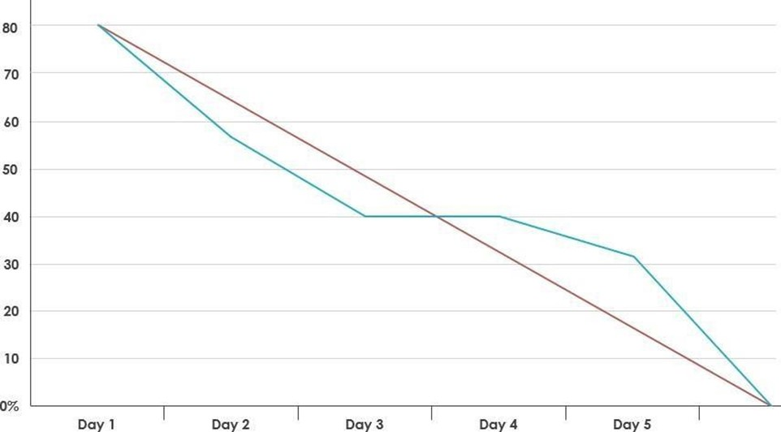**Burndown Chart:**